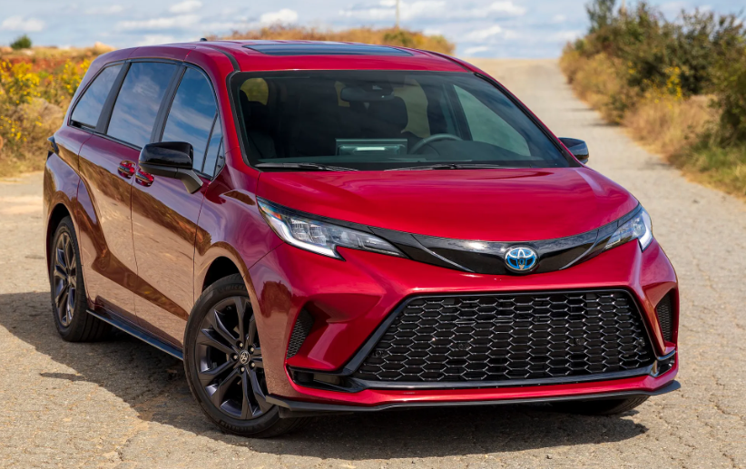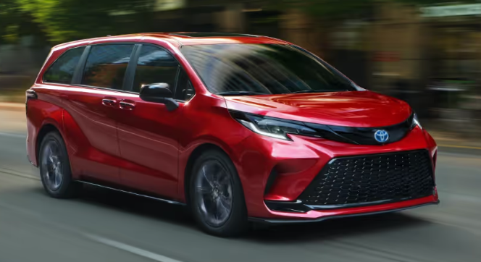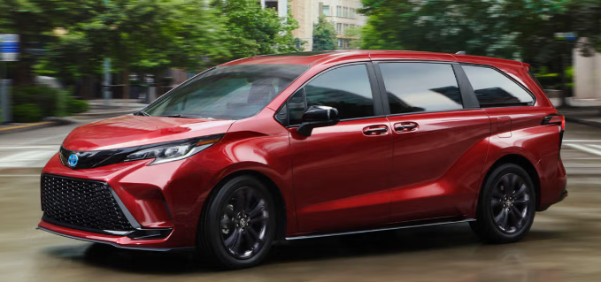

**Main Specifications** for the **2025 Toyota Sienna**

**🚗 Powertrain & Performance**

* **Engine**: 2.5 L inline-4 Atkinson-cycle petrol + electric motors (hybrid only)
* **Combined Output**: 245 hp (hybrid system) — 189 hp from the engine + 180 hp electric motor
* **Torque**: 176 lb‑ft @ 4,400 rpm (engine) + ~199 lb‑ft from electric motor
* **Transmission**: ECVT (electric continuously variable), manual-shift capable
* **Drivetrain**: FWD standard; AWD available (additional rear electric motor)
* **Fuel Economy**: ~36 mpg combined (city/highway)
* **Fuel Tank**: 18.0 gal
* **Towing Capacity**: Up to 3,500 lb when equipped

**📐 Dimensions & Capacities**

* **Length × Width × Height**: 203.7 ″ × 78.5 ″ × 68.5 ″
* **Wheelbase**: 120.5 ″ **Ground Clearance**: ~6.3″ (~160 mm)
* **Curb Weight**: ~4,610 lb (varies by trim)
* **Interior Volume**
* **Seating**: 7–8 passengers (configurable trims)
* **Passenger Volume**: ~159.7–162.5 cu ft
* **Cargo Volume**:
  + Behind 3rd row: 33.5 cu ft
  + Behind 2nd row: 75.2 cu ft
  + Max (front seats folded): 101 cu ft

**🛞 Chassis, Suspension & Brakes**

* **Front Suspension**: MacPherson struts
* **Rear Suspension**: Multi-link independent
* **Brakes**: 4-wheel ventilated disc with ABS/EBD/brake assist
* **Wheels/Tires**:
  + Standard: 17″ (235/65R17)
  + Upgrades: 18″ (235/60R18) or 20″ (235/50R20) on higher trims

**🔒 Safety & Driver-Assistance**

* **Airbags**: Up to 10 airbags (front, side, curtain, knee)
* **Toyota Safety Sense 3.0**: Includes adaptive cruise (DRCC), lane tracing, blind-spot, rear-cross traffic, pedestrian/cyclist detection, road sign assist, automatic high-beam
* **Advanced Rear Seat Reminder**: Radar-based alert system for forgotten passengers or pets
* **Optional Tech**: 360° surround-view camera, front/rear parking sensors available on XLE/Platinum

**🧰 Infotainment & Convenience**

* **Multimedia Screen**: 8.0″ standard; up to 12.3″ available
* **Digital Instrument Cluster**: 12.3″ available on higher trims
* **Connectivity**: Wireless Apple CarPlay/Android Auto, Bluetooth, Wi-Fi hotspot, wireless charging, multiple USB ports
* **Rear Entertainment**: Available roof-mounted screen and JBL audio package on upper trims
* **Luxury Features (Platinum)**: Hands-free power sliding doors, power liftgate, panoramic view monitor, fridge & vacuum (introduced 2025)

**🛡️ Warranty**

* **Basic**: 3 yr/36,000 mi
* **Powertrain**: 5 yr/60,000 mi
* **Hybrid components**: 10 yr/150,000 mi

**🏆 Accolades**

* Named **Best Overall Minivan** in 2025 by *Parents* magazine for its hybrid efficiency and family-oriented tech
* Edmunds praise for leading hybrid fuel economy (~36 mpg) and strong tech suite

**✅ Summary**

The 2025 Toyota Sienna is an efficient hybrid-only minivan, offering:

* Powerful yet smooth hybrid drivetrain
* Excellent fuel economy (~36 mpg)
* Flexible seating (7–8) and ample cargo
* Strong safety tech, including advanced rear seat alerts
* AWD option and luxury trim features like onboard vacuum and fridge
* Leading warranty coverage